Freanu A. Peria 1710126 January 7, 2019

BSCS CS 302 – Modeling and Simulation CS32FC1 Sir Rey Castillo

Prelim Exam

1.a.

Naïve Forecasting Technique

This forecasting technique simply uses the last period’s actual output value as the forecast for a current period’s forecast, without any attempt of adjusting or establishing any mathematical improvements. This technique is generated only for comparison to other higher-level forecasting techniques. What I did was that I implemented the technique in python 3. The data that I used, “Peso-Dollar exchange rate in the Philippines”, was taken from the site [www.data.gov.ph](http://www.data.gov.ph).

(note: on my subsequent implementation of forecasting techniques, i will be using Numpy and Pandas for manipulating data. Matplotlib is used for plotting data on a graph)

1.a. Source Code:

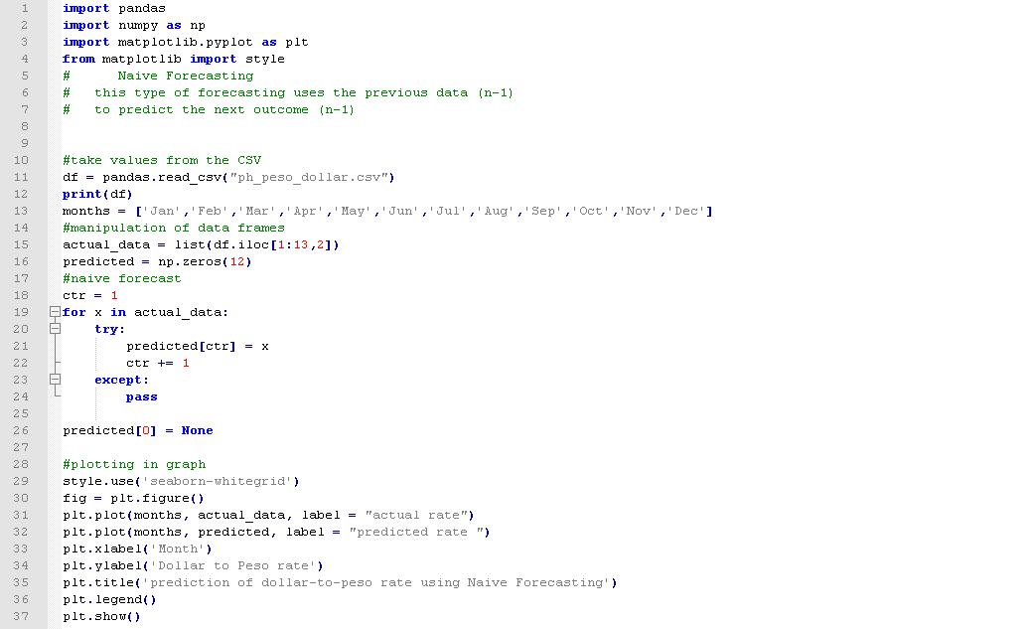

1.a

Graph

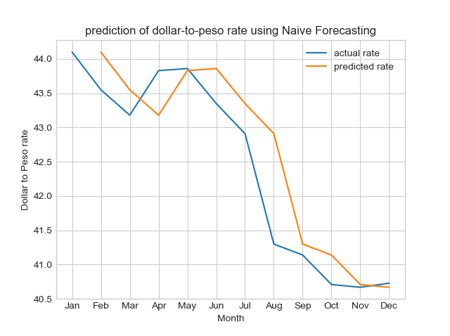

1.b – Simple Average Technique

On this implementation, I simply aggregated all of the data and took its average, and used the average as the forecasted amount, since there I can’t find any “Simple Average Forecasting Technique” on the internet and books. I used the same data from the previous forecasting technique.

1.b. – Source Code

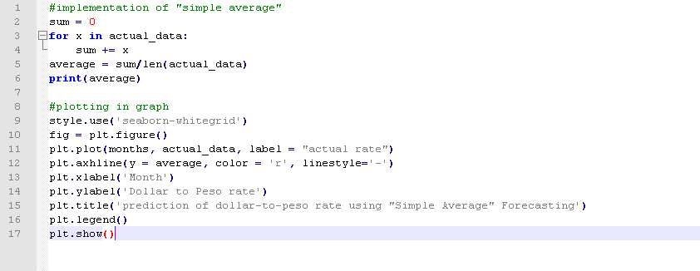

1.b. – Graph

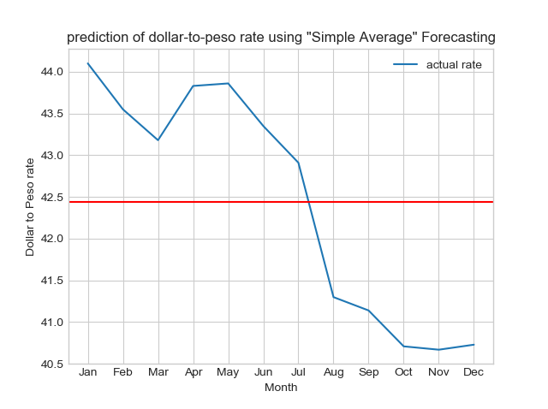

1.c. Moving Average

This forecasting technique uses the n previous values, takes the average of it and uses it as the forecasted value. It reduces the randomness of the forecast by averaging values over a period of time. In my implementation, the data that I used, “Carbon Emission of Countries from 1960 to 2014”, was taken from World Bank Open Data (https://data.worldbank.org/). I used three-year and five-year period for my implementation, resulting in two lines of forecast. The line of the five-year period is more sensitive to sudden changes in trend in the actual data. It is quite so, as seen on the graph.

1.c. Source Code

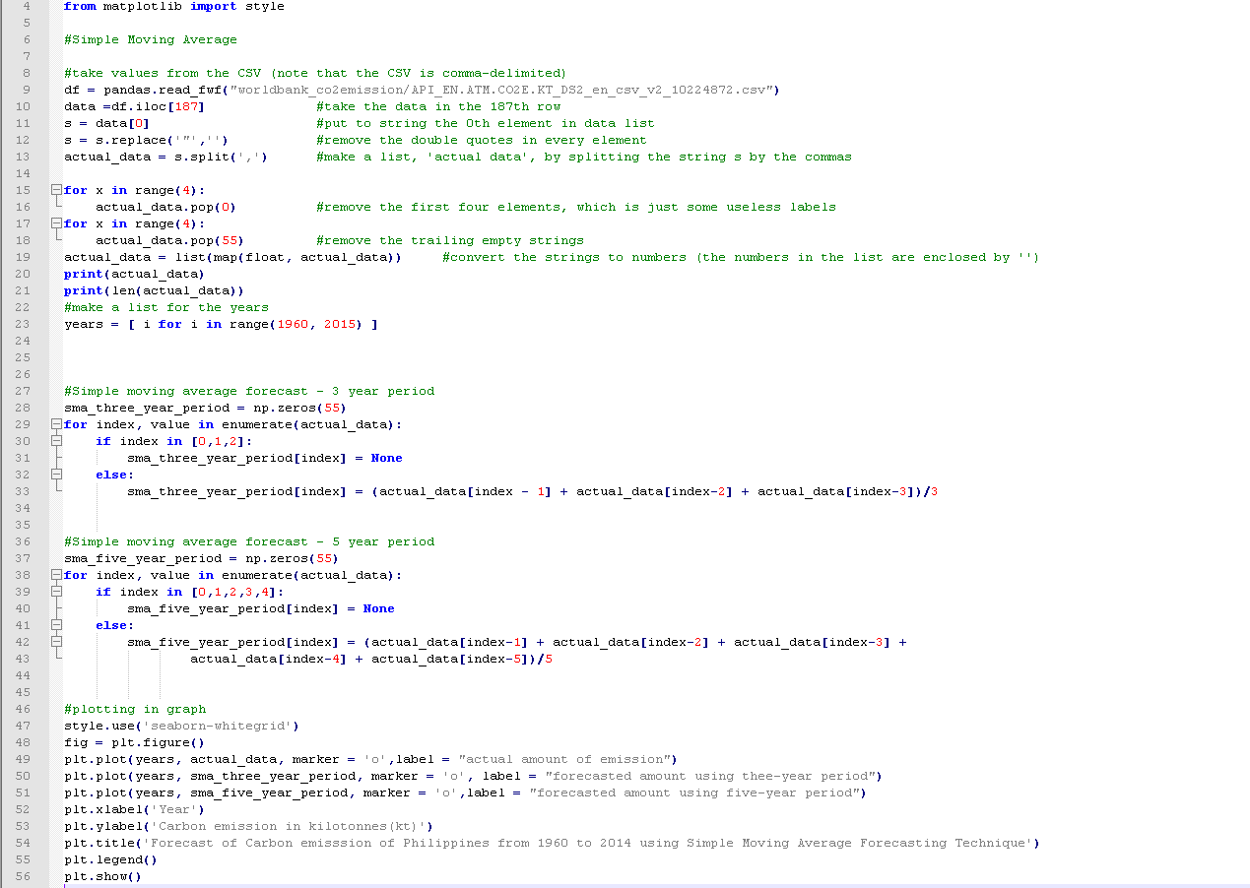

1.c. Graph

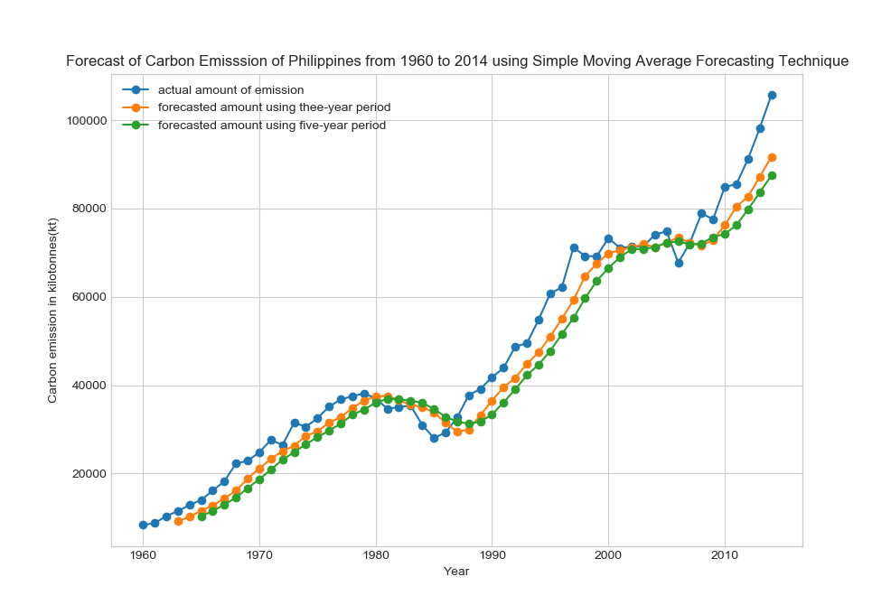

1.d. Weighted Average

Like the moving average forecasting, it relies on the preceding values in order for it to forecast the current value. In this technique, for every actual value that contributes to the forecasted value, it has its own bearing depending on how far it is from the forecasted value. That is, it will give more “weight” to the most recent value. In my implementation, I took values in a four-year period, and I distributed the alpha as shown:

|  |  |  |  |  |
| --- | --- | --- | --- | --- |
|  | 1 | 2 | 3 | 4 |
| Alpha | 0.4 | 0.3 | 0.2 | 0.1 |

1.d Source Code

(I removed the block of code that dealt with processing data and plotting)

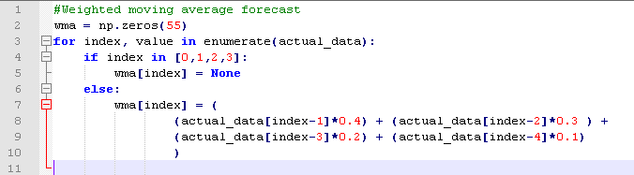

1.d. Graph

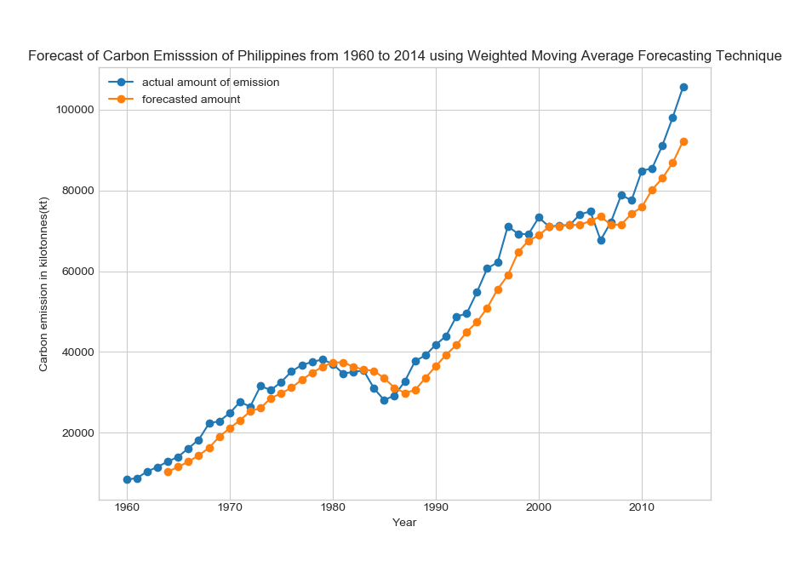

1.e. Exponential Smoothing

Exponential Smoothing technique uses the previous actual value and forecasted value in order to forecast the current value. The actual and forecasted value will be affected by the alpha, which is between 0 and 1. It uses the formula Ft+1 = Ft + α(At – Ft). The forecast of Exponential Smoothing usually starts at the third term, since it assumes that the first predicted value = actual value, then carried over to the second term. Notice that the forecasting technique “smooths out” the line of the actual data.

1.e. Source Code

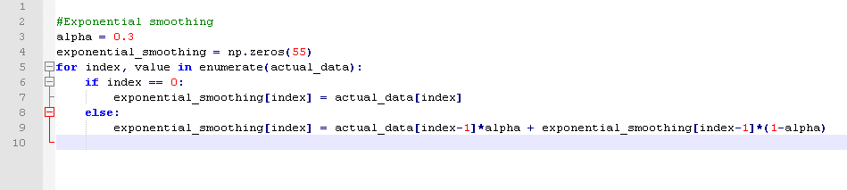

1.e. Graph

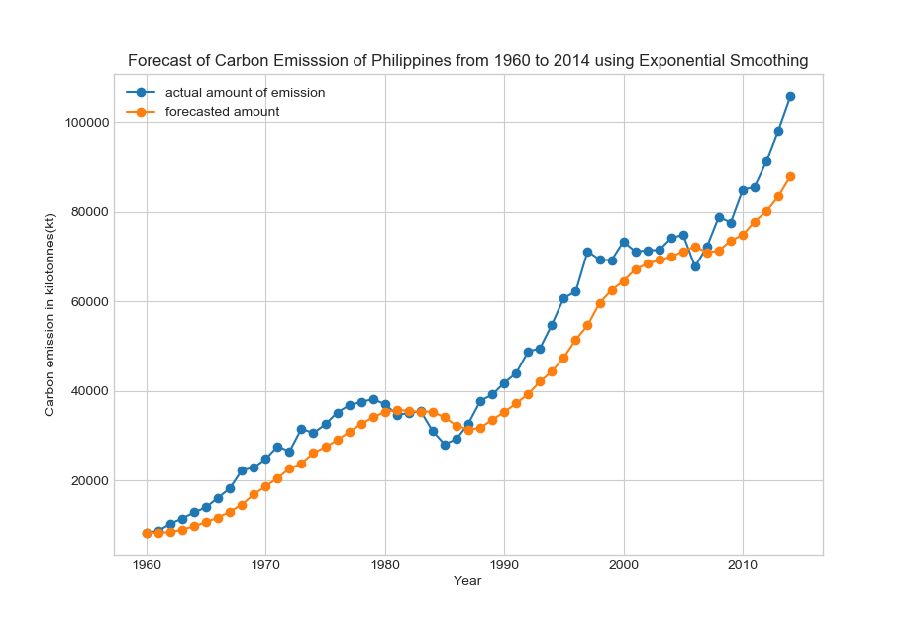

1.f. Linear Trend Line

This forecasting technique is as simple as a linear equation; it aggregates all of the actual value and uses it to formulate the slope and the y-intercept of the line. It uses the formula Y = a + bt , where

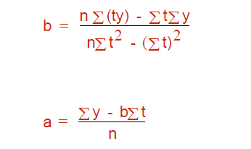

1.f. Source Code

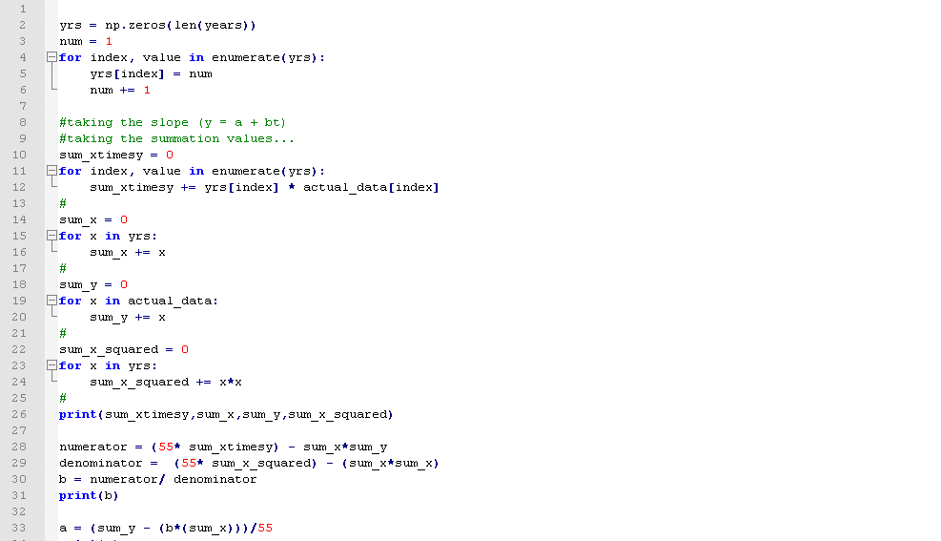

1.f. Graph

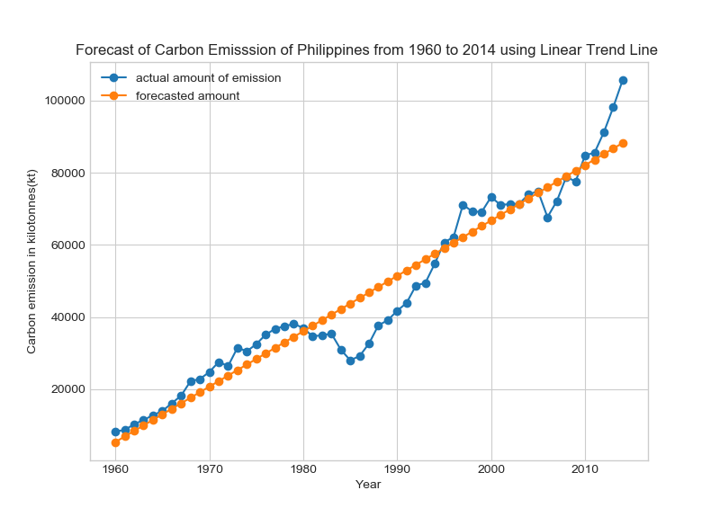

1.g. Forecasting Seasonality Technique

Again, I was not able to find “Forecasting Trend” and “Forecasting Seasonality” in my search. What I have learned from my study was that, you can take into account while implementing the linear trend line the seasonality of a dependent variable depending on the period, thus *forecasting the trend and seasonality*. In my implementation, I have chosen to observe the data by decades, thus having five cycles of ten-year periods. For every nth year, I took the sum and averaged it. Then each yearly average is then divided by the grand average (average of all the yearly average) – these values shall be used to adjust the value forecasted by the linear trend line. The implementation of the Forecasting Seasonality Technique was not quite effective, as shown in the graph; perhaps observing the data by decade is a wrong decision.

1.g. Source Code

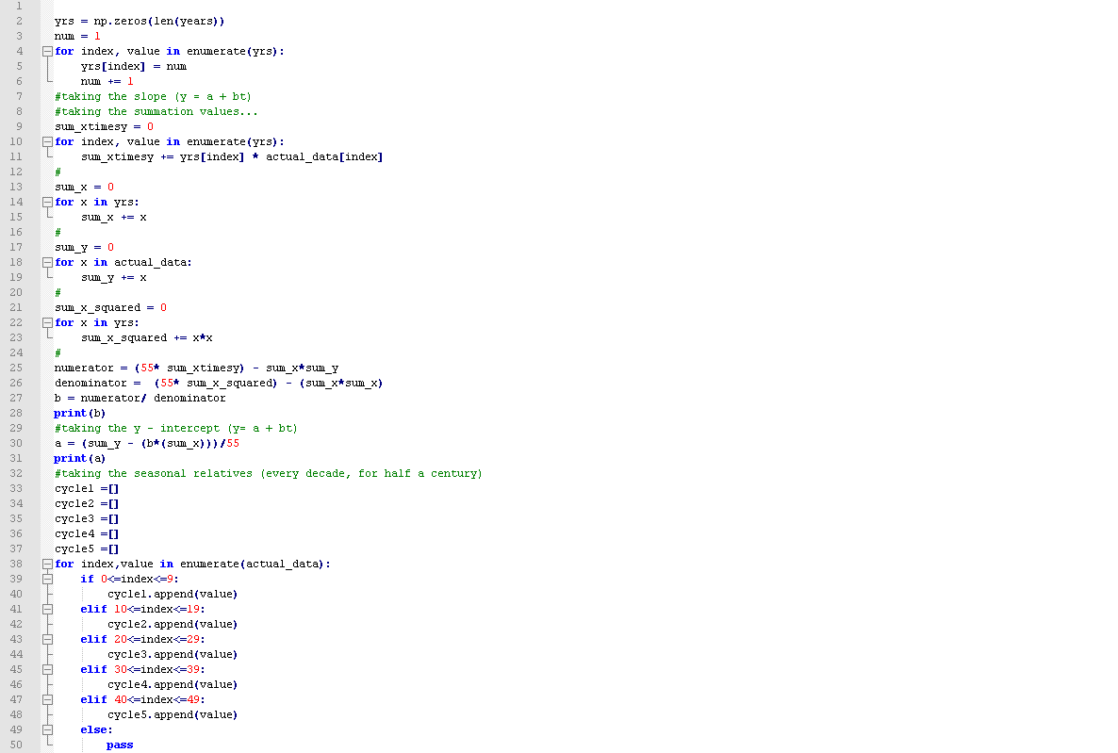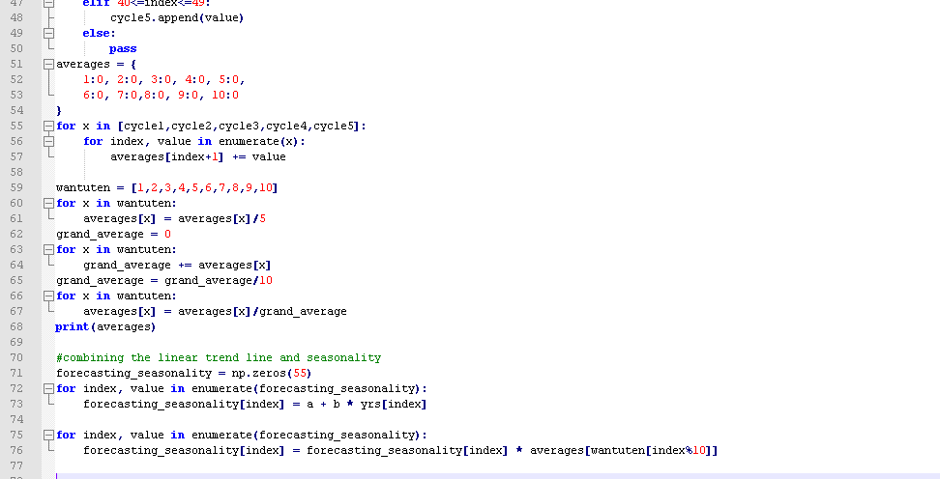

1.g. Graph

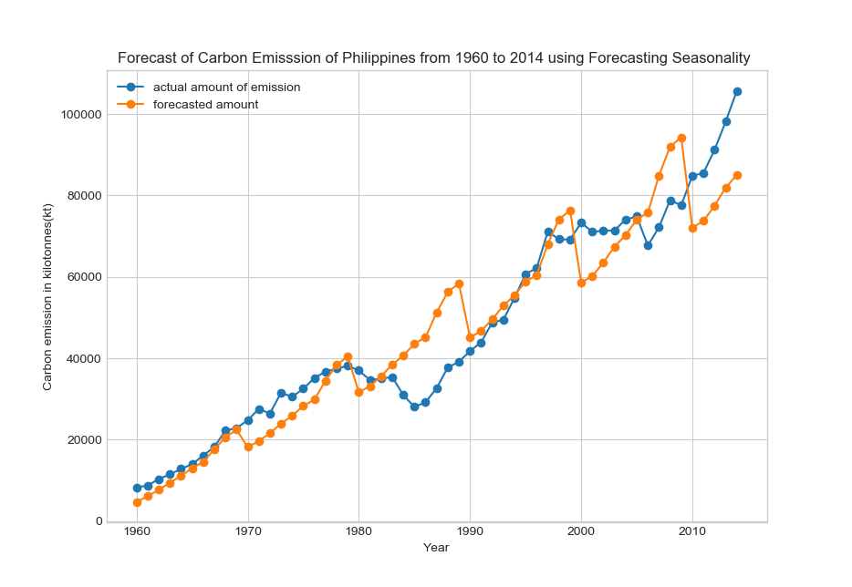

2.a. Linear Regression

Linear Regression is simply a line that forecasts value of a dependent variable based on the independent variable. It explains the relation and causality between two variables that are related (i.e. healthcare and mortality rate, poverty and crime rate). In my model, I used the same data set from the first forecasting technique, assuming that the peso-dollar rates are dependent on the month of the year, possibly because of Filipinos who work as OCW bringing home Foreign currencies, thus adjusting the value of the Philippine Peso.

2.a. Source Code

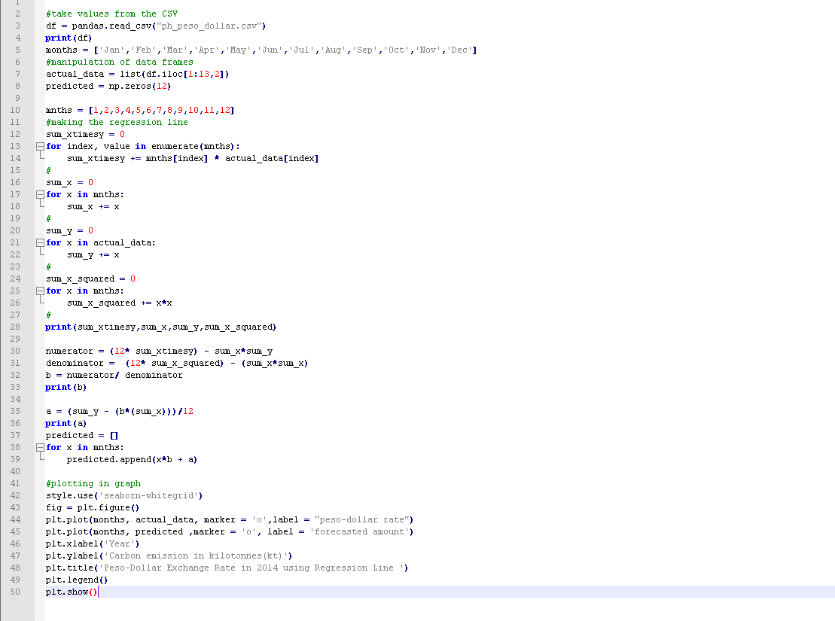

2.a. Graph

